User Manual

Description: This product is an automated pill container to serve as a reminder for your medical needs. Consists of a wooden circular box and two separate circuits to serve as a reminder indicator and the other as a controller to get the box to rotate as necessary.

Loading the Application:

Step 1 – Upon starting the Raspberry Pi, click on the Folder icon in the top left-hand corner


1
2
3
Step 2 – Next Click on the “ITCS2875” Folder
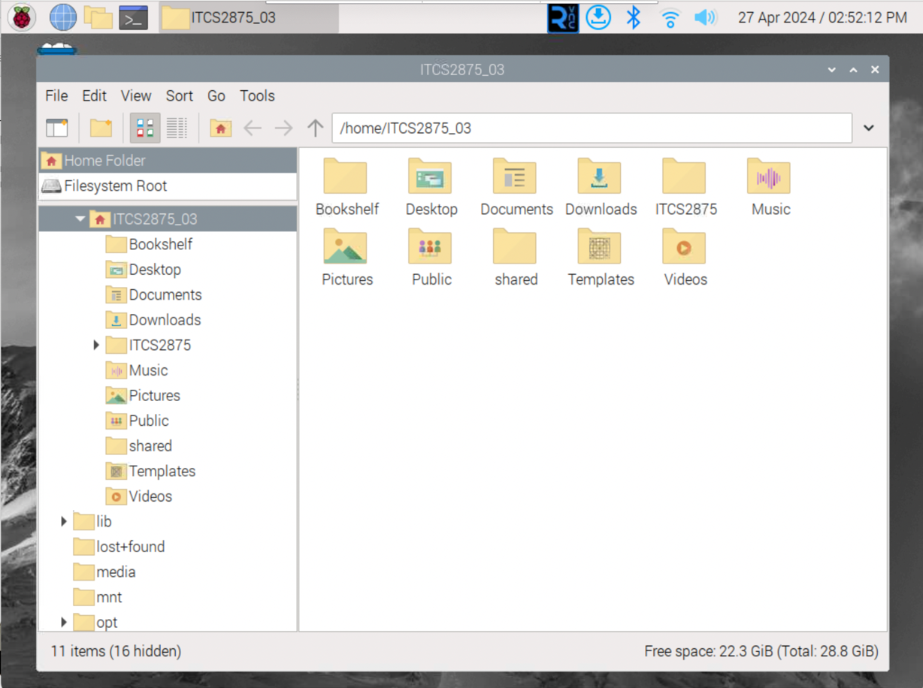

Step 3 – Then click on the “Final” Folder
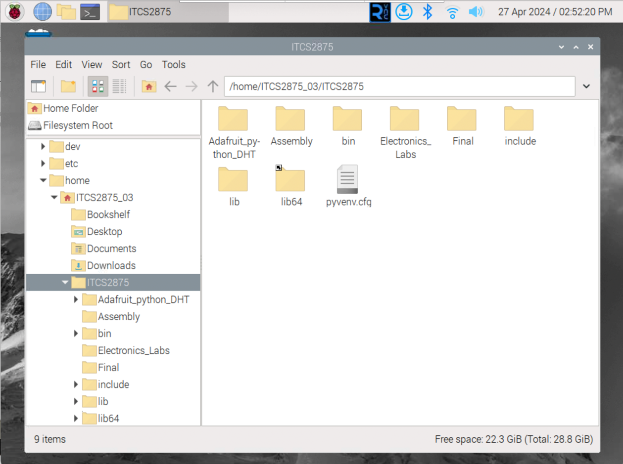

Step 4 – Right click on the python file “Young_final_code.py”
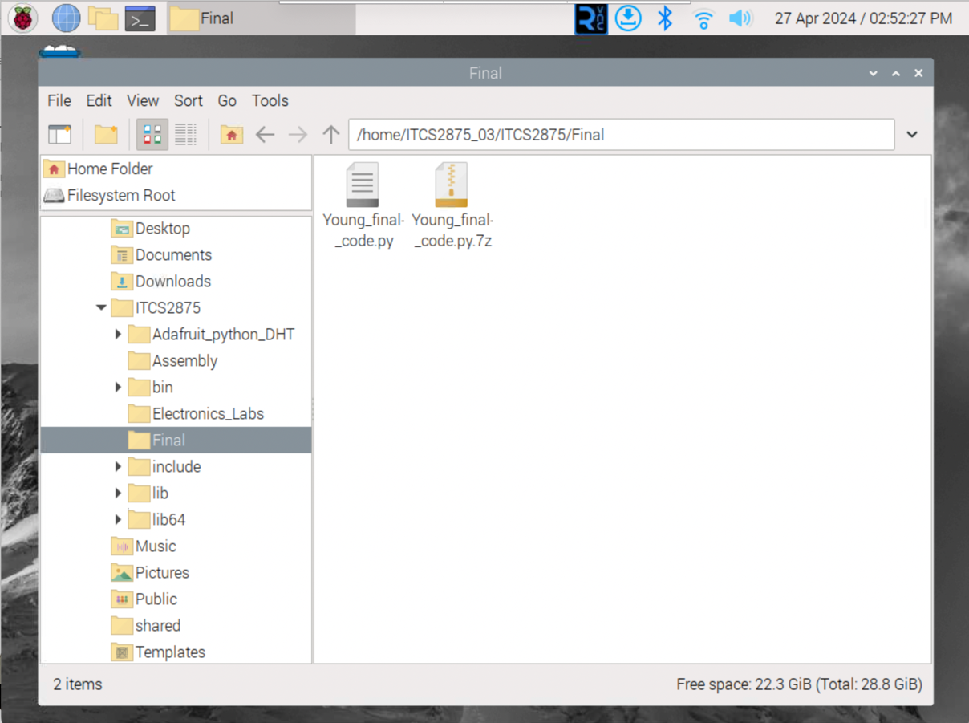

Step 5 – Select the Thonny IDE application to open the code file
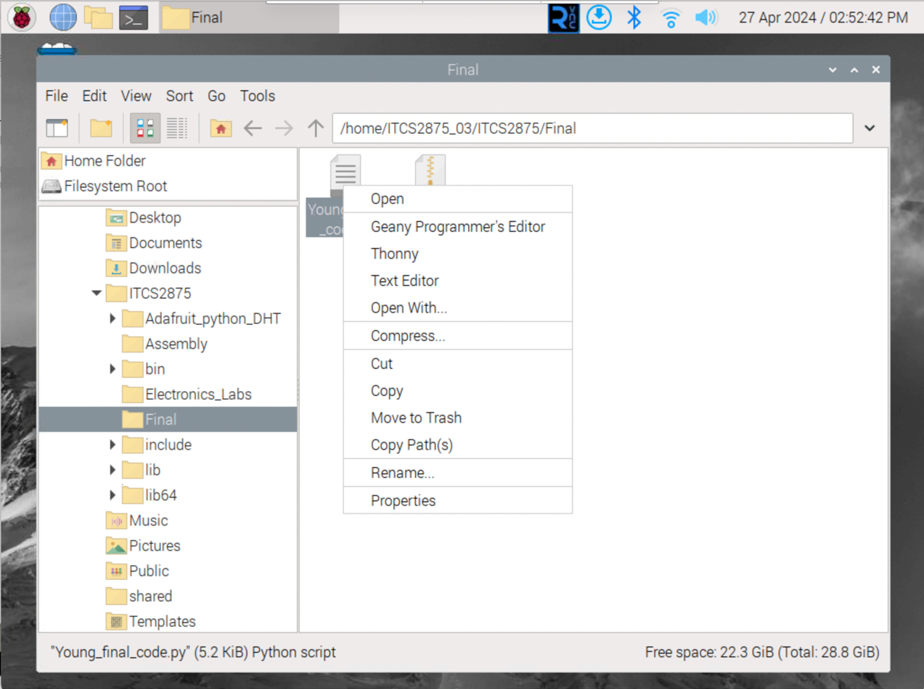

Step 6 – Select the green play button in the top-left corner to run the program
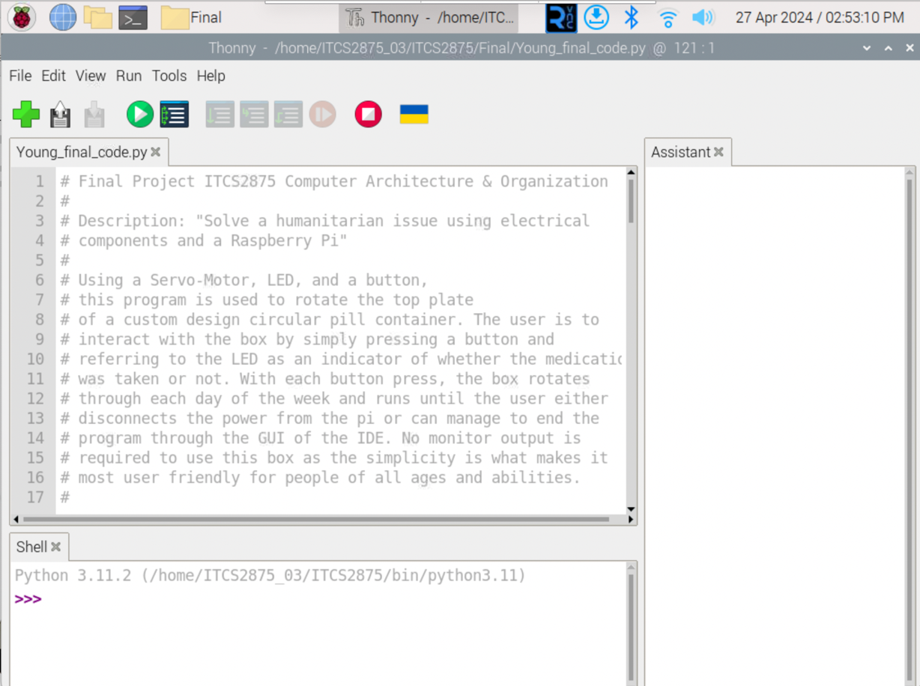

Working the Box

Once you have successfully begun to run the code application, the instructions are fairly straightforward. Use the button to make the box rotate to each new day. NOTE: There is a brief time delay in between each button press. This is because the box is on a timer so that the LED will turn on and off at the appropriate times to remind you of when to take your medicine. Only if the LED is on, can you interact with the button.

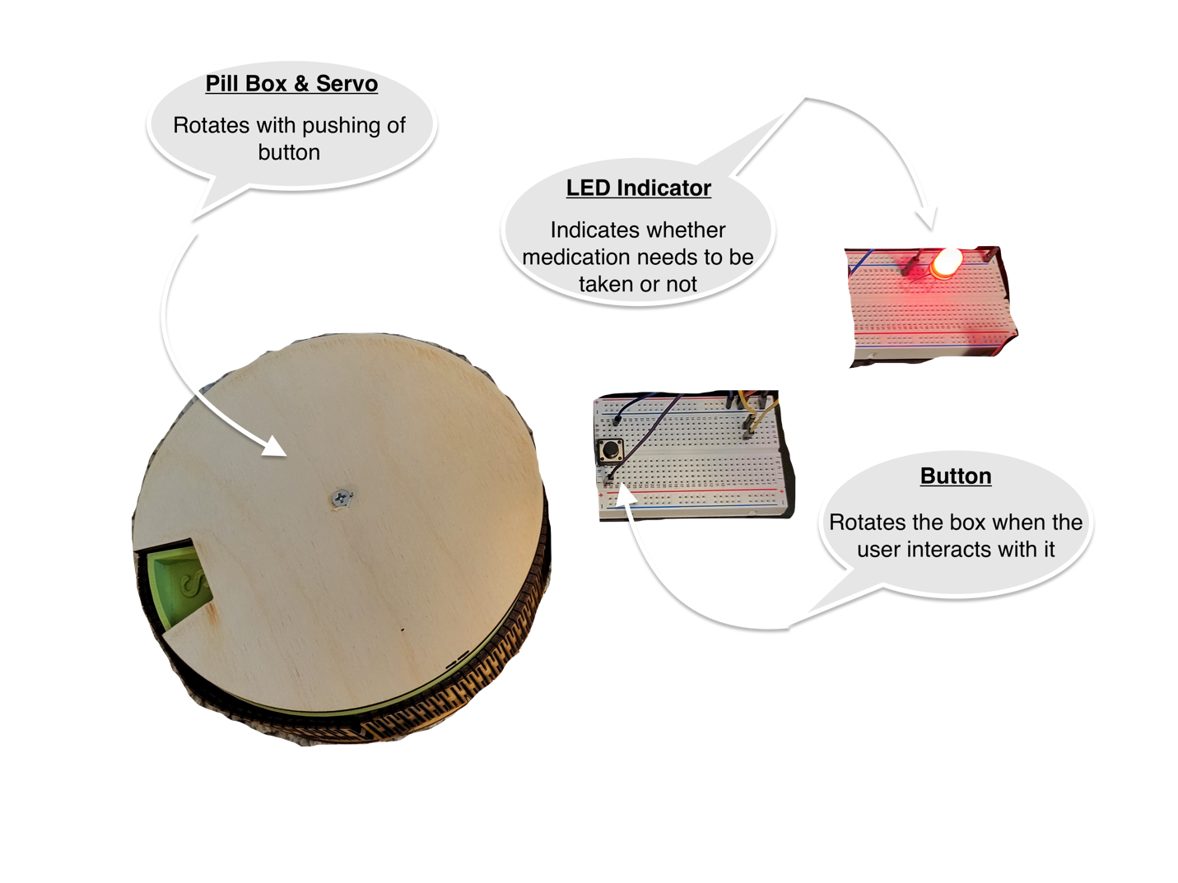
Refilling the box:

When the time comes to refill the box, simply adjust the “sleep” variable within the code to a smaller number such as 0.5 seconds so that it will minimize the down time between button presses. You can adjust the timing here:
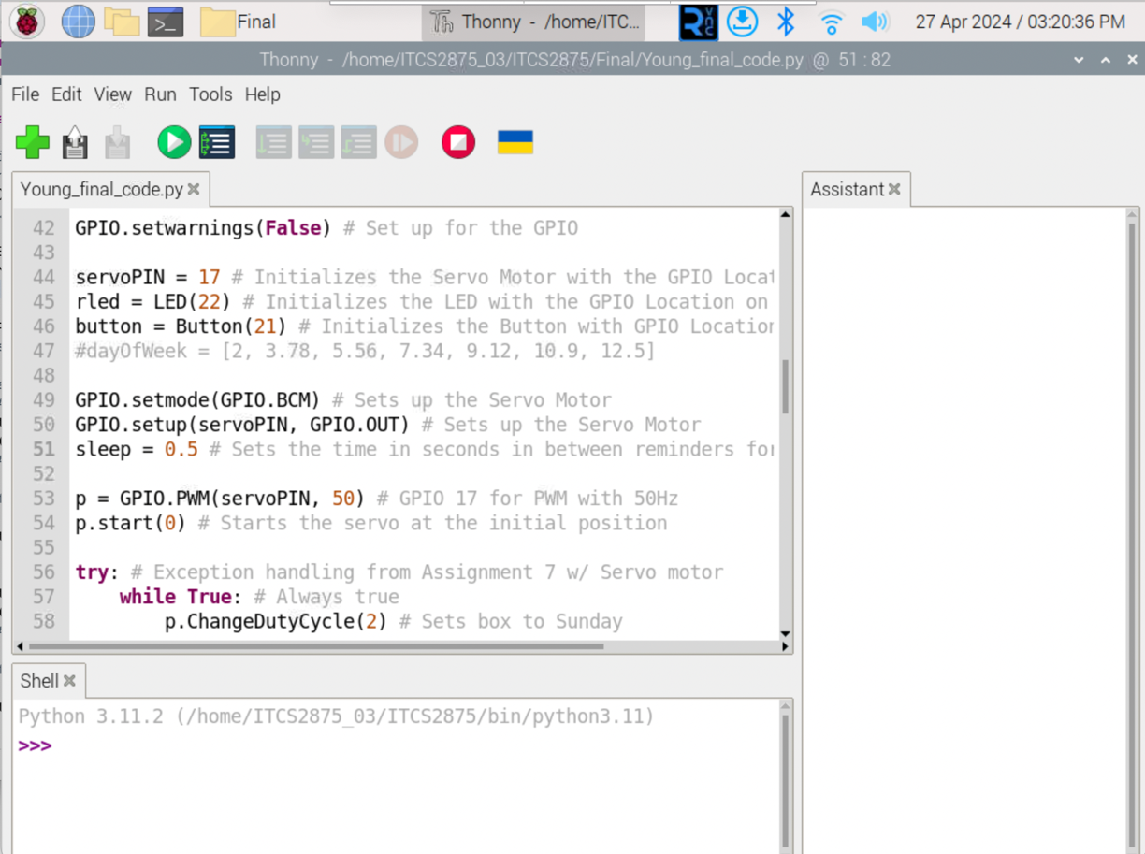

Glossary

Button – the main source of the users input to interact with this device

IDE – short for “Integrated Development Environment” and is essentially a place where software developers write and test code throughout the programming process

LED – stands for “Light-Emitting Diode”, for this product it serves as the indicator where ON requires you to interact with the device and OFF indicates that you do not need to interact with the device

Servo – this is a type of motor encapsulated within the box and is what drives the rotation underneath the lid

Raspberry Pi – this is the central unit to the entire function of this device; it is a small computer capable of being able to control and orchestrate communication between the electrical components that make the device run and function

